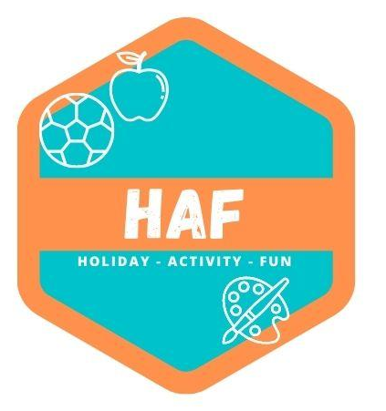

Complaints Policy
At West Lancs HAF we aim to work in partnership with parents to deliver a high-quality service for everyone. If for any reason we fall short of this goal, we would like to be informed in order to amend our practices for the future. Our complaints policy is displayed on the premises at all times. Records of all complaints are kept for at least three years. A summary of complaints is available for parents on request.
The camp manager is usually responsible for dealing with complaints. If the complaint is about the camp manager, a senior member of staff within the West Lancashire HAF team will investigate the matter. Any complaints received about staff members will be recorded on a Complaints log and will be dealt with in the following manner:
Stage one
Complaints about aspects of camp activity:
- The camp manager will discuss the matter informally with the parent or carer concerned and aim to reach a satisfactory resolution.
Complaints about an individual staff member:
- If appropriate the parent will be encouraged to discuss the matter with staff concerned.

- If the parent feels that this is not appropriate, the matter will be discussed with the camp manager, who will then discuss the complaint with the staff member and try to reach a satisfactory resolution.
Stage two
If it is not possible to reach a satisfactory resolution to the complaint through informal discussion, the parent or carer should email their complaint in writing to the West Lancashire HAF team at
westlancs.haf@gmail.co.uk.
The West Lancashire HAF team will:
- Acknowledge receipt of the email and make contact within 2 working days.
- Investigate the matter and notify the complainant of the outcome within 5 working days.
- Send a full response in writing, to all relevant parties, including details of any recommended
changes to be made to the camp’s practices or policies as a result of the complaint.
- Meet relevant parties to discuss the camp’s response to the complaint, either together or on an individual basis if required/appropriate.

If child protection issues are raised, the camp manager will refer the situation immediately to the HAF Designated Safeguarding Lead for that day, who will follow the procedures set out in the Safeguarding Children Policy. If a criminal act may have been committed, the camp manager will contact the police.

This policy was adopted by: West Lancs HAF | Date: 20/03/2023
Reviewed on: 21/06/25  To be reviewed: 21/06/26 | 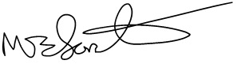  Signed: M.Forster

